**Course ___Methods_Test 4_ Year __12_______**

Student name: ________________ Teacher name: ________________

Date: **Weds 26 August**

**Task type: Response**

**Time allowed for this task: _____45______ mins**

**Number of questions: _____6______**

**Materials required:** Calculator with CAS capability (to be provided by the student)

Standard items: Pens (blue/black preferred), pencils (including coloured), sharpener, correction fluid/tape, eraser, ruler, highlighters

Special items: Drawing instruments, templates, notes on one unfolded sheet of   
A4 paper, and up to three calculators approved for use in the WACE examinations

**Marks available: __46____ marks**

**Task weighting: __10__%**

**Formula sheet provided: Yes**

**Note: All part questions worth more than 2 marks require working to obtain full marks.**

Q1 (1, 1, 1 & 3 = 6 marks)

Consider a continuous random variable X that is uniformly distributed as follows.

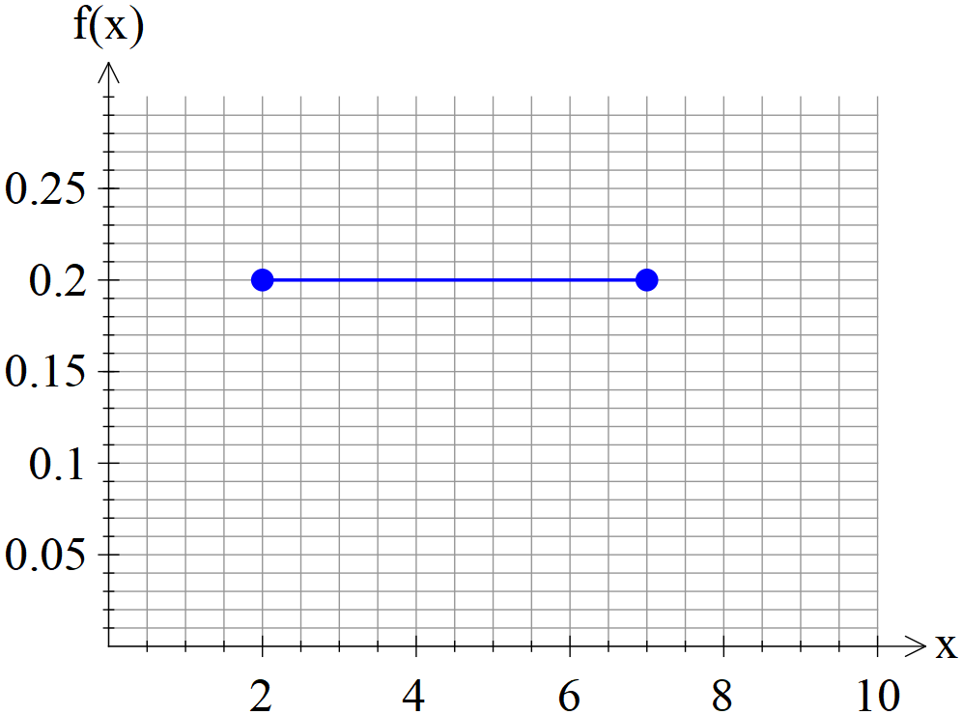

Determine the following:

1. 
2. 
3. 
4. 

Q2 (3 marks)

Consider a continuous random variable X shown below.

Solve for the constant **exactly.** (Show all working)



 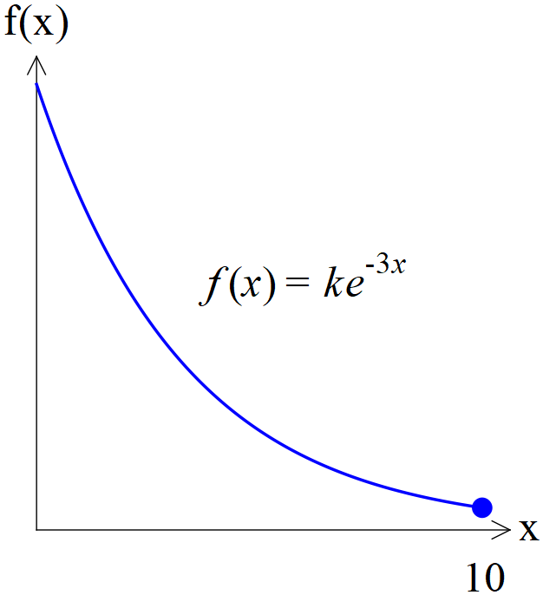

Q3 (1 , 4, 1 & 2 = 8 marks)

Consider a continuous random variable X shown below. (Not drawn to scale)

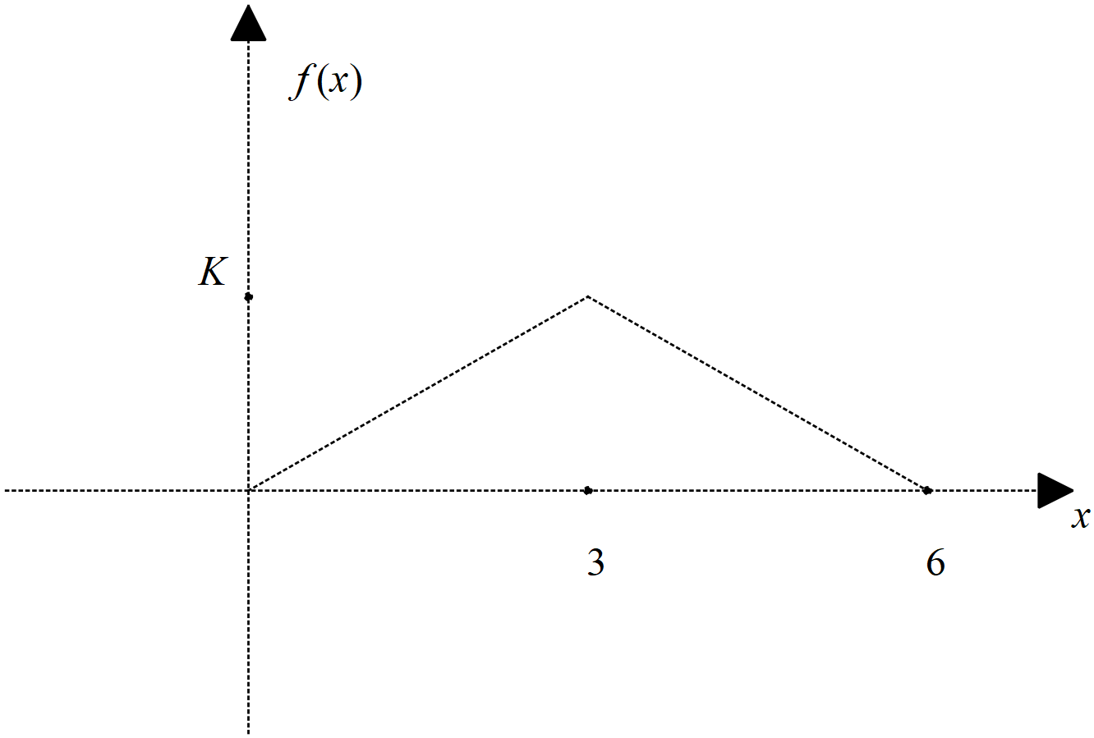

1. Determine the value of the constant .
2. Determine 
3. Determine 
4. Determine Standard deviation of 

Q4 (2, 2 ,2 & 1 = 7 marks)

A continuous random variable,  has a pdf 

Determine:

1. 
2. 
3. Standard deviation
4. 

Q5 (2, 2, 2 & 3 =9 marks)

The results for a class test,  can be modelled by a Normal Distribution given by .

Determine:

1. The 78th percentile.
2. 
3. The cut-off for an A grade given that this grade is only given to the top 20%.
4. A second test is a Normal Distribution with a mean of 55. Given that the 58th percentile is 62, determine the standard deviation.

Q6 (3, 3, 3, 2 & 2 =13 marks)

The time it takes to be served at a supermarket checkout,  seconds, can be modelled by a normal distribution as follows  seconds. The assistant at the check out is paid according to the following scheme.

|  |  |  |  |  |  |
| --- | --- | --- | --- | --- | --- |
| Time served  In seconds |  |  |  |  |  |
| Payment $P | $5 | $7 | $12 | $15 | $18 |
| Probability  To 4 decimal places |  |  |  |  |  |

1. Fill in the probability line of the above table rounded to three decimal places.
2. Determine the expected payment  showing full working.
3. Determine the variance of the payment  showing full working.
4. If the payments were all increased by 30% and a bonus of $2 added to each category, determine the new mean and standard deviation.
5. Explain a limitation of the Normal distribution model and show a calculation to support this.